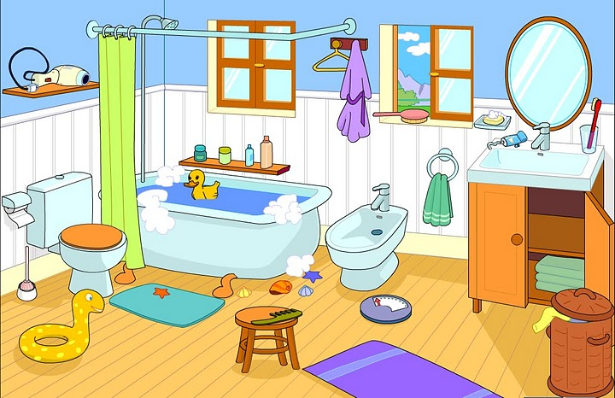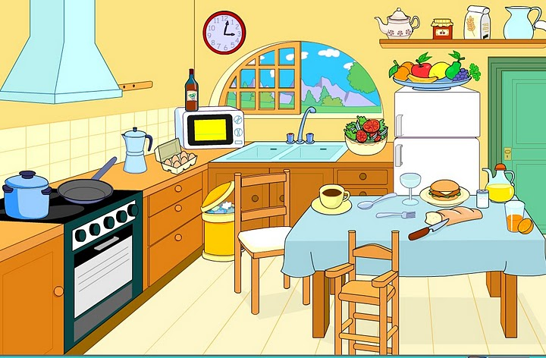

TRUE OR FALSE Prawda czy fałsz- napisz z boku T lub F

1- THE CHAIR IS NEXT TO THE DESK

2-THE BEDS ARE OPPOSITE THE WINDOWS

3-THE COMPUTER IS UNDER THE DESK

4-THE BOOKCASE IS ON THE WALL.

5-THE BIN IS BETWEEN THE BED AND THE DESK

6-THE LAMP IS ON THE DESK.

7-THE POSTER IS ABOVE THE SHELF

8-THE WINDOWS ARE ABOVE THE BEDS

9-THE CLOCK IS ON THE BED.

CHOOSE THE RIGHT OPTION (Zaznacz kolorem właściwy przyimek)

1-THE FRIDGE IS BETWEEN/UNDER THE DOOR AND THE CUPBOARD.

2-THE DOOR IS NEXT TO/UNDER THE SHELF (półka).

3-THE CLOCK IS IN/ON THE WALL.

4-THE CHAIRS ARE UNDER/ NEXT TO THE TABLE

5-THE TABLE IS UNDER/OPPOSITE (naprzeciwko)THE COOKER.

6-THE POT IS ON/IN THE COOKER.

7-THE BIN IS NEAR/ IN FRONT OF THE DRAWERS (szuflady).

8-THE MICROWAVE IS NEXT TO /UNDER THE WINDOW

9-THE SINK IS ABOVE (nad)/UNDER THE WINDOW.

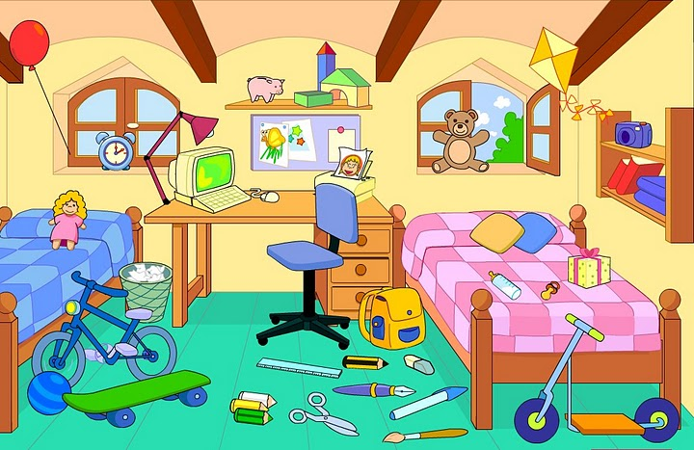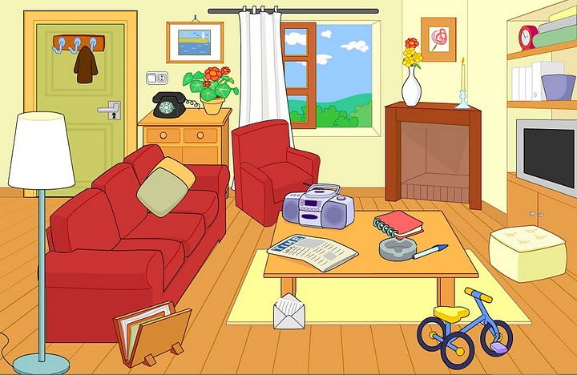

MULTIPLE CHOICE (Zaznacz właściwy przyimek)

1- THE DOOR IS…………… THE TELEPHONE

UNDER - NEXT TO – OPPOSITE

2-THE T.V IS …………..THE SOFA

NEAR – OPPOSITE – BEHIND

3-THE MAT (mata)IS …………….THE TABLE

UNDER – BEHIND – ABOVE

4-THE PICTURE IS ……………THE WINDOW AND THE DOOR.

IN – ON – BETWEEN

COMPLETE WITH THE RIGHT PREPOSITION (napisz właściwy przyimek)

1-THE TOILET IS ………………..THE BATH

2-THE CURTAIN IS………………….THE TOILET AND THE BATH.

3-THE SHELF IS …………….THE WALL

4-THE MIRROR IS …………….THE WASHBASIN

5-THE CUPBOARD IS …………………..THE WASHBASIN (umywalka)

6-THA MAT IS ………………..THE TOILET

7-THE STOOL(stołek) IS ……………….THE BATH.

8-THE BIN IS ………………..THE CUPBOARD.

9-THE TOWELS(ręczniki) ARE ……………..THE CUPBOARD.