Angielski - 20

- Powitanka

https://www.youtube.com/watch?v=x23rTDl4AMs
Lyrics:
Hello, Hello, how are you?
Hello, Hello, how are you?
Hello,
Hello,
How are you?
How are you today?

I am fine; I am great
I am fine;
I am just great
I am fine; I am great
I'm very well today!
Great!

Hello, Hello, how are you?
Hello, Hello, how are you?
Hello, Hello, How are you?
How are you today?

I am hungry; I am tired
I am hungry; I am tired
I am hungry; I am tired
I'm not so good today.

Ah, well I hope you feel better soon!

Hello,
Hello,
How are you?
Hello,
Hello,
How are you?
Hello,
Hello,
How are you?
I'm very well today!
- ,,If you’re happy and you know it” - zabawa muzyczno - ruchowa.

https://www.youtube.com/watch?v=71hqRT9U0wg

- ,,Rock, scissors, paper” - zabawa paluszkowa.

https://www.youtube.com/watch?v=P65yE_EXLd8

- rock - kamień, skała [rok] (dłoń złożona w pięść)
- scissors - nożyczki [sizors] (wyciągnięte palec wskazujacy i środkowy)
- paper - papier [pejper] (cała dłoń)

- How’s the weather? - Jaka jest pogoda?

https://www.youtube.com/watch?v=I8GeA3anPdo

- sunny - słonecznie [sani]
- rainy - deszczowo [rejni]
- cloudy - pochmurnie [kloudi]
- windy - wietrznie [łindi]
- snowy - pada śnieg [snołi]

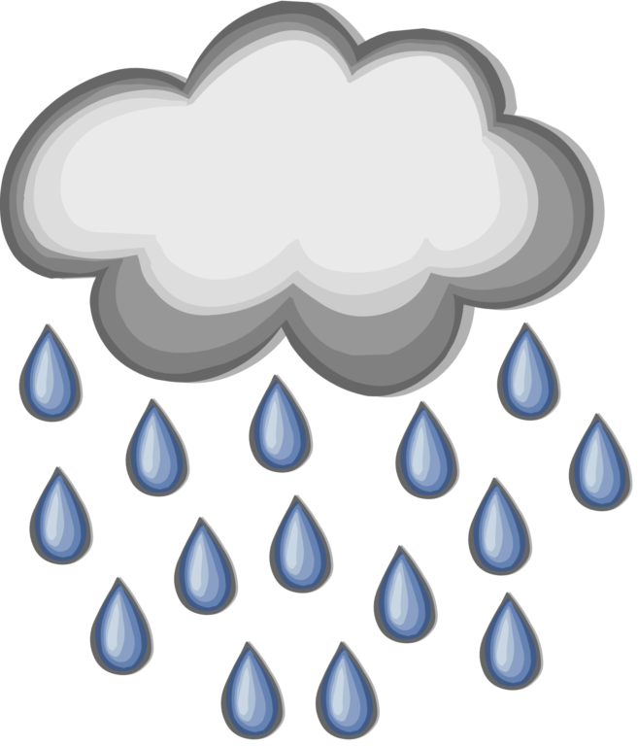

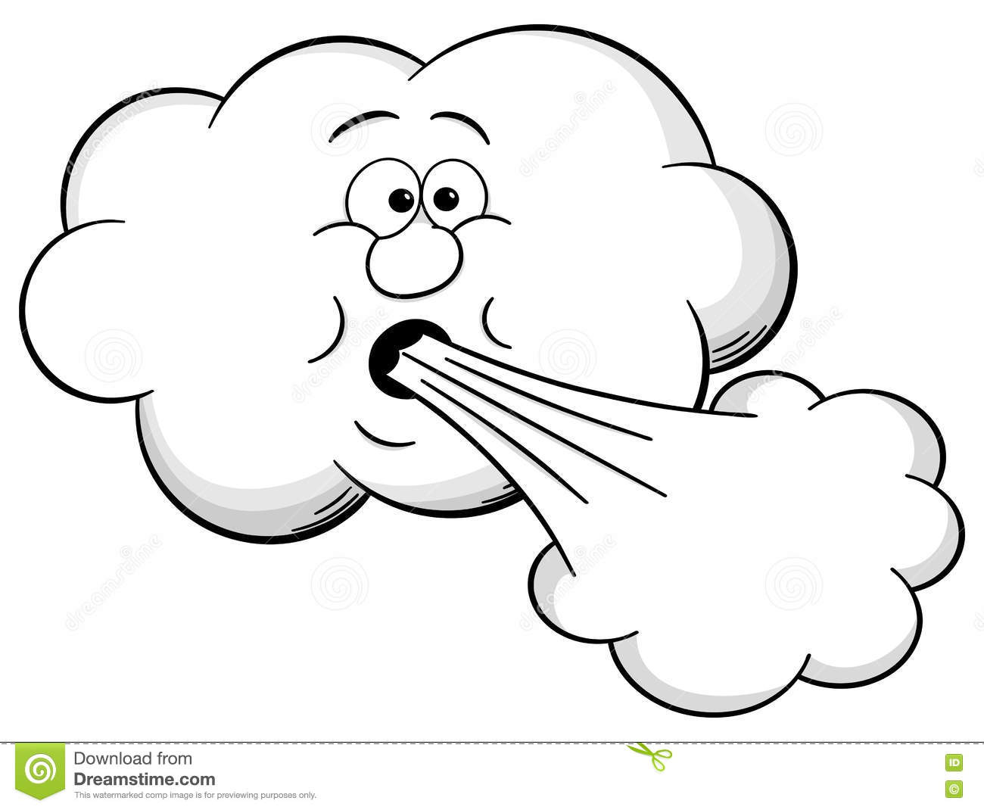

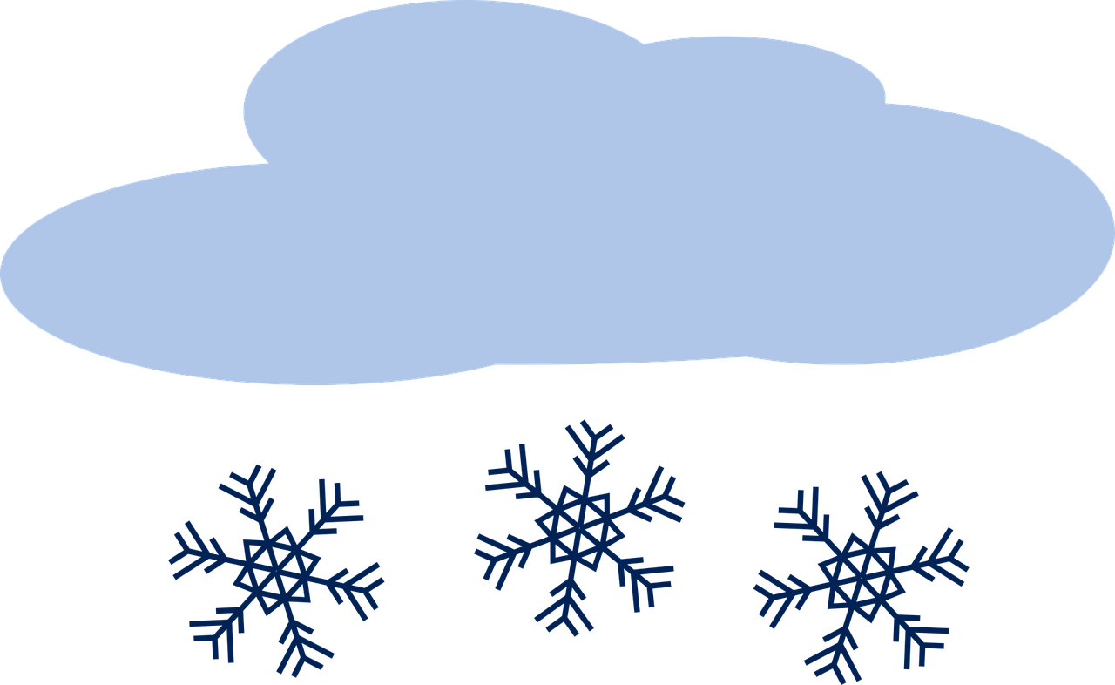

- ,,What do you hear?” - Co słyszysz?

- dog - pies [dog]
- cat - kot [ket]
- duck - kaczka [dak]
- rooster - kogut [ruyster]
- pig - świnka [pig]
- elephant - słoń [elefant]

https://www.youtube.com/watch?v=YVgv1EFJZHc&t=9s

- ,,Eeney Meeney Miney Moe’’ - zabawa wyliczanka

https://www.youtube.com/watch?v=uDjOeb7xEy4

