Skontroluj si riešenia v pracovnom zošite: 5A My room
42/ 2
2. a bed
3. a bedside table
4. a chest of drawers
5. a desk
6. a chair
7. a carpet
8. a rug

42/ 3
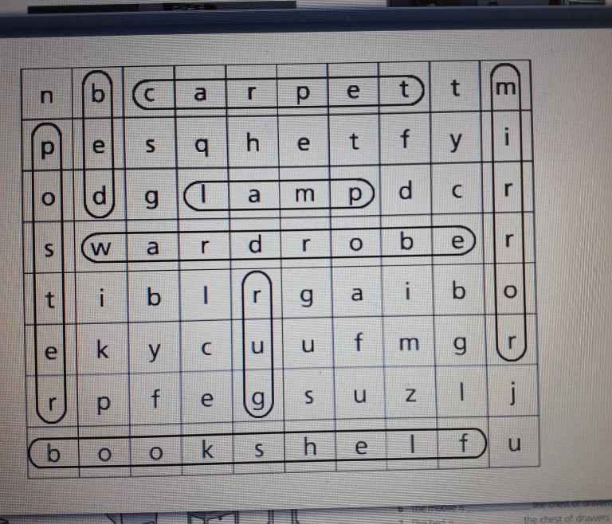

42/ 3
2. bedside table
3. chest of drawers
4. bed
5. wardrobe
6. rug
7. lamp
8. desk

43/ 5
2. False The magazines are on the table.
3. False The bed is next to the wardrobe.
4. False The football is in the wardrobe.
5. False The box is under the bed.
6. True
7. False The rug is under the table.
8. False The violin is behind the chest of drawers.

43/ 6 43/ 7
2. in 2. Owen
3. on 3. Mia
4. behind 4. Jake
5. next to 5. Leo
6. under 6. Robert
7. between
43/ 8
Vlastné odpovede

