Jarná práce v záhrade 28.4.2020

Práca v záhrade:

* pohrabeme lístie

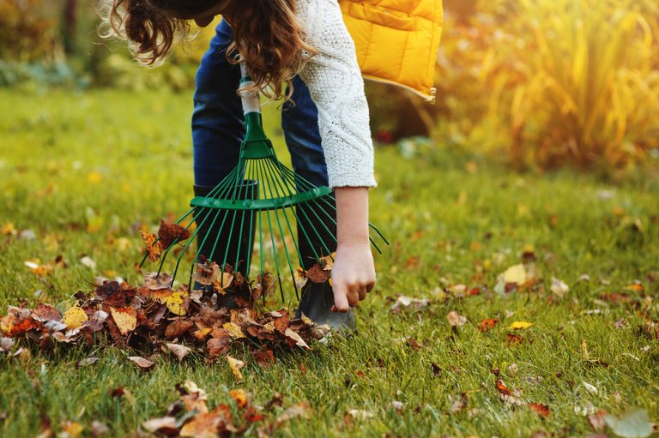

* orežeme suché konáre

[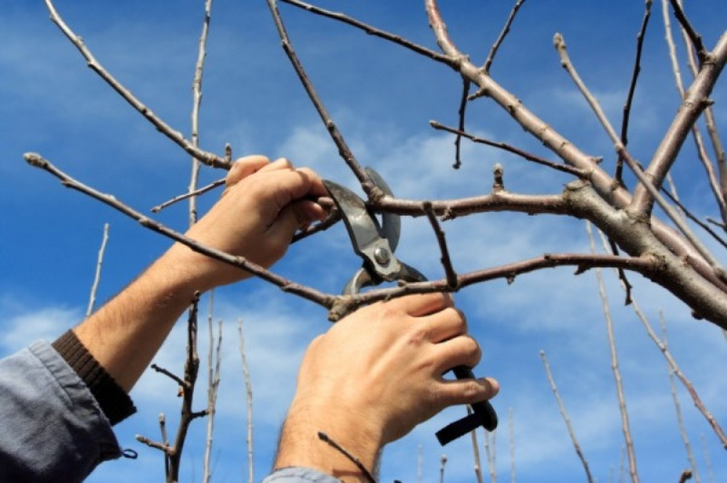](https://www.google.sk/url?sa=i&url=https://www.chovatelahospodar.sk/tema/strihanie-ovocnych-stromov-v-troch-jednoduchych-krokoch&psig=AOvVaw3_f4tz86RW5K6DHSz0ELyA&ust=1588148236988000&source=images&cd=vfe&ved=0CAIQjRxqFwoTCLiFtbXXiukCFQAAAAAdAAAAABAD)

* kyprenie pôdy kutivátorom a prevydušnenie pôdy

[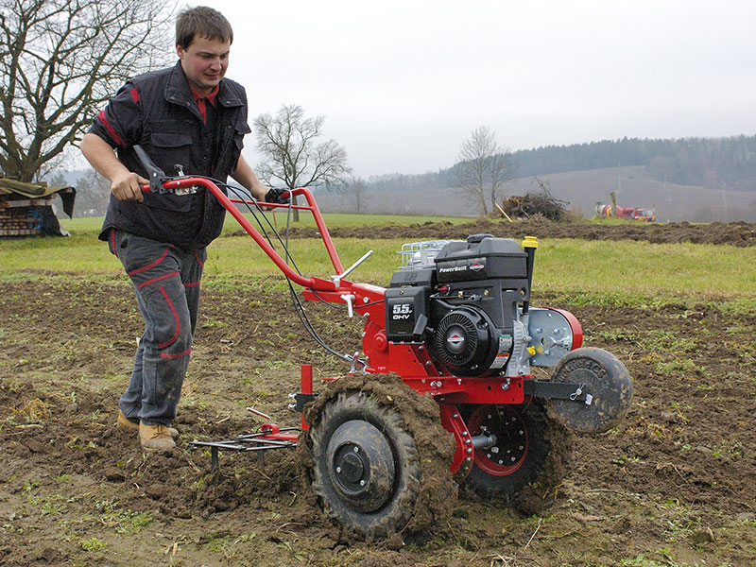](https://www.google.sk/url?sa=i&url=https://www.mountfield.sk/kypric-19/16-1kuz1006&psig=AOvVaw00z8OWjDAjr0x-RnNiwwQj&ust=1588148488787000&source=images&cd=vfe&ved=0CAIQjRxqFwoTCLjajajYiukCFQAAAAAdAAAAABAP)

* sadenie

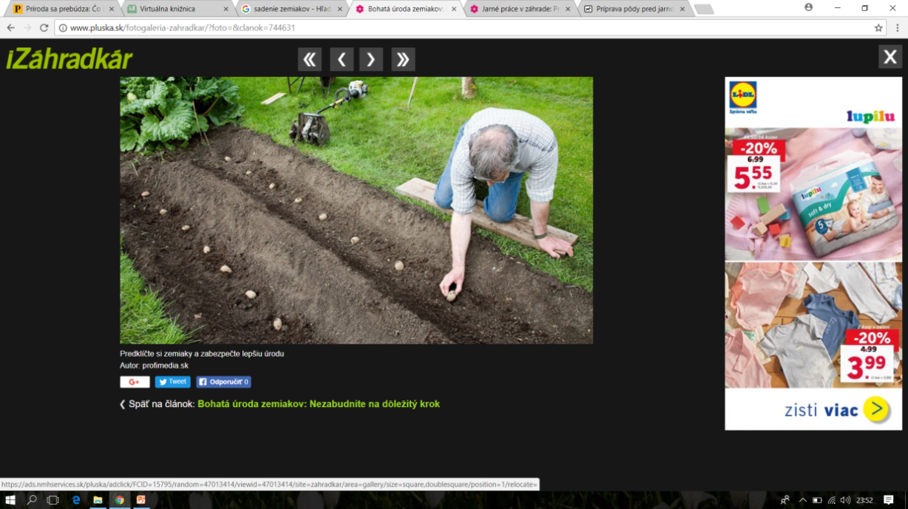 

V záhrade sadíme zeleninu:

[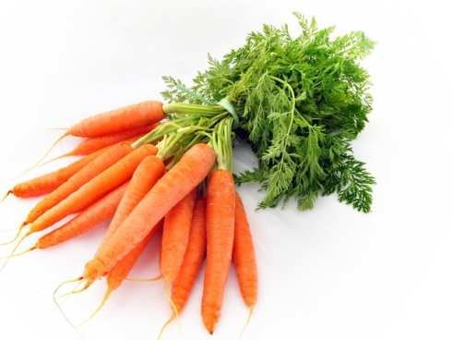](https://www.google.sk/url?sa=i&url=https://napisali.sk/clanky/medzinarodny-den-mrkvy&psig=AOvVaw1Gsr9w51FbDTE2Wz0cih-I&ust=1587626484654000&source=images&cd=vfe&ved=0CAIQjRxqFwoTCLCY7eC_--gCFQAAAAAdAAAAABAD)[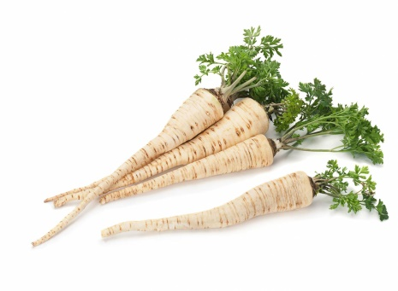](https://www.google.sk/url?sa=i&url=https://bylinke.sk/sk/stranka/bylinky/petroselinum-crispum&psig=AOvVaw21VRAwQW1bCvaTUn9ITjpc&ust=1587626593801000&source=images&cd=vfe&ved=0CAIQjRxqFwoTCPiO4ZrA--gCFQAAAAAdAAAAABAD)

MRKVA PETRŽLEN

[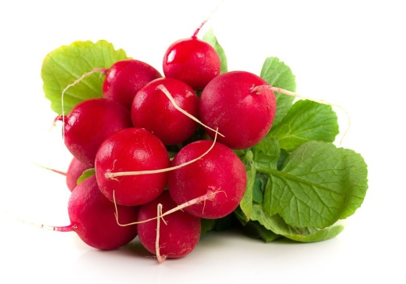](https://www.google.sk/url?sa=i&url=https://zena.pravda.sk/jedlo/clanok/463655-redkovka-nici-bakterie-a-rozpusta-zlcove-kamienky/&psig=AOvVaw0euniL9Pt6q6-h9ZEiwTFT&ust=1587626032178000&source=images&cd=vfe&ved=0CAIQjRxqFwoTCKij8Je---gCFQAAAAAdAAAAABAD) [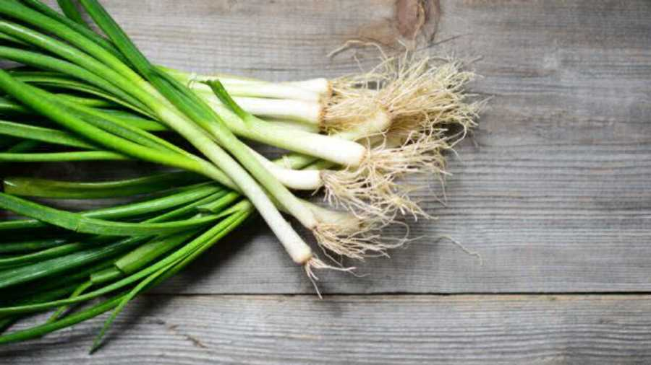](https://www.google.sk/url?sa=i&url=http://www.podbrezovan.sk/zazrak-zvany-jarna-cibulka/&psig=AOvVaw2xYC4fYTFiWsIwpN5o4n9k&ust=1587626296405000&source=images&cd=vfe&ved=0CAIQjRxqFwoTCNiQ5Zi_--gCFQAAAAAdAAAAABAD)

REĎKOVKA CIBUĽKY

[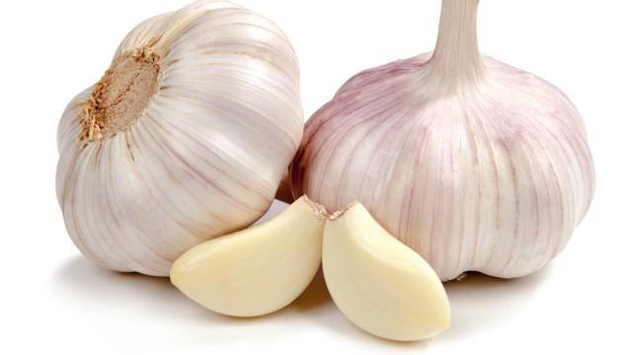](https://www.google.sk/url?sa=i&url=https://www.bohatstvo-prirody.sk/klas-cesnak-a-petrzlen/&psig=AOvVaw1WJ1tbHPEJq_MxMLUjKaAV&ust=1588149307595000&source=images&cd=vfe&ved=0CAIQjRxqFwoTCNiFs7vbiukCFQAAAAAdAAAAABAE) [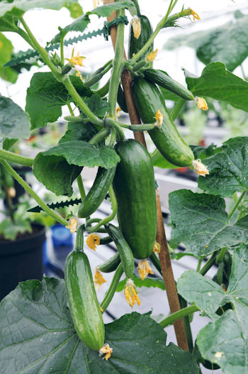](https://www.google.sk/url?sa=i&url=https://urobsisam.zoznam.sk/zahrada/rastlina-dna/previsnuta-uhorka-ministar&psig=AOvVaw3PL4g4to4pJ1B_MetYtWk6&ust=1587628112863000&source=images&cd=vfe&ved=0CAIQjRxqFwoTCOi90-PF--gCFQAAAAAdAAAAABAJ)

CESNAK UHORKY

[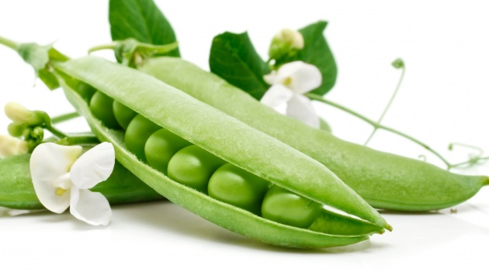](https://www.google.sk/url?sa=i&url=https://dran.webnoviny.sk/hrasok-plny-vitaminov/&psig=AOvVaw3gf5qNbQy_V9NZ6jFafvJP&ust=1588149589143000&source=images&cd=vfe&ved=0CAIQjRxqFwoTCPCN-7rciukCFQAAAAAdAAAAABAD) [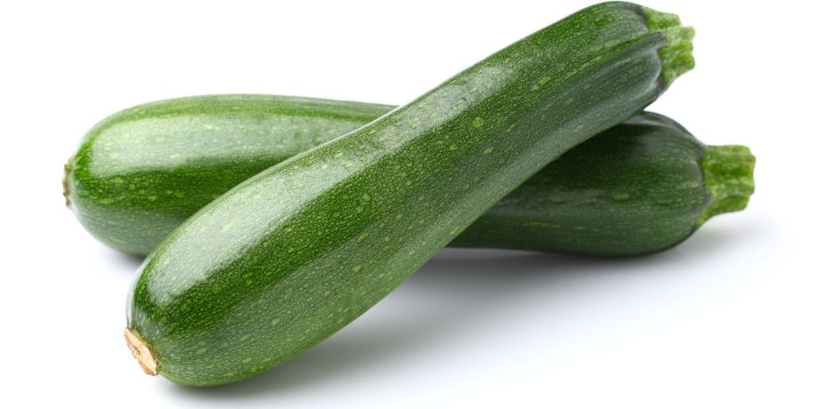](https://www.google.sk/url?sa=i&url=https://dobruchut.aktuality.sk/clanok/35119/cuketa-idealny-pomocnik-na-chudnutie-a-detox/&psig=AOvVaw3IwEPZsIKleDJkSJRIs-LQ&ust=1588149752287000&source=images&cd=vfe&ved=0CAIQjRxqFwoTCOigwozdiukCFQAAAAAdAAAAABAD)

HRÁŠOK CUKETY

[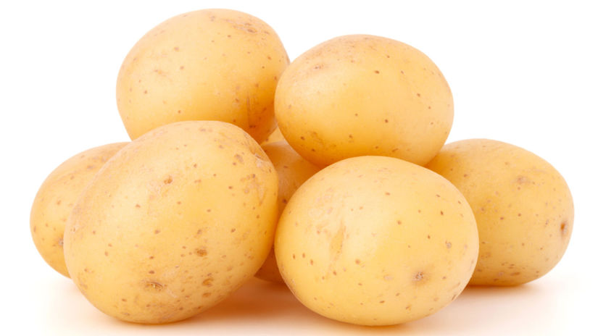](https://www.google.sk/url?sa=i&url=https://zdravie.pravda.sk/zdrava-vyziva/clanok/431544-kolko-sacharidov-denne-konzumovat-aby-sme-schudli/&psig=AOvVaw1IeX1mZF7M5N-YXEdwCpRU&ust=1588150414206000&source=images&cd=vfe&ved=0CAIQjRxqFwoTCIjpqsHfiukCFQAAAAAdAAAAABAM)

ZEMIAKY

Priesady

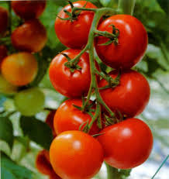 [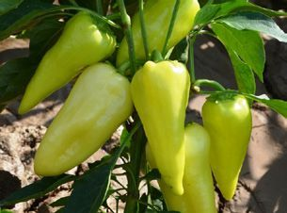](https://www.google.sk/url?sa=i&url=https://www.pinterest.com/pin/94083079703007691/&psig=AOvVaw34gtlI1rkEFLzSd0IC11b9&ust=1587627971762000&source=images&cd=vfe&ved=0CAIQjRxqFwoTCMDMx6bF--gCFQAAAAAdAAAAABAJ)

PARADJKY PAPRIKY

[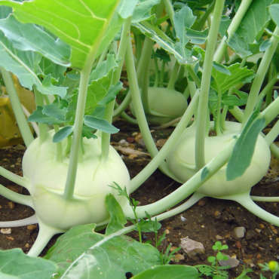](https://www.google.sk/url?sa=i&url=https://zdravopedia.sk/zelenina/kalerab-10-ucinkov-na-zdravie&psig=AOvVaw2F5hjPX5jLvUgy6dNCRkhm&ust=1588150003871000&source=images&cd=vfe&ved=0CAIQjRxqFwoTCIjUr5veiukCFQAAAAAdAAAAABAD) [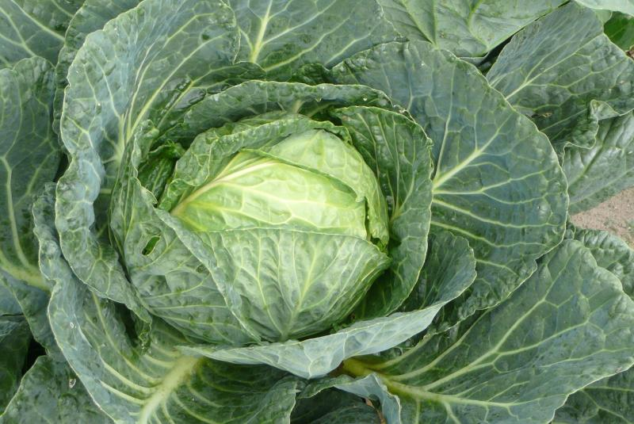](https://www.google.sk/url?sa=i&url=https://www.mimibazar.sk/clanek/772/hlavkova-kapusta-necakany-zazrak&psig=AOvVaw0tIHvtaVPdpjHsqU2eOBi8&ust=1588150182795000&source=images&cd=vfe&ved=0CAIQjRxqFwoTCKiYsdzeiukCFQAAAAAdAAAAABAI)

KALERÁB KAPUSTA

Pozrite si video ☺

<https://www.youtube.com/watch?v=F6U3Br5xSW8>

Náradie, ktoré používame v záhrade

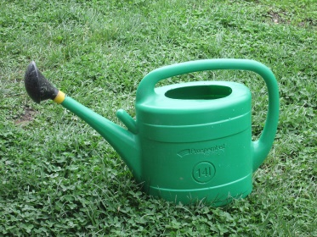

POLIEVACIA KRHLA

[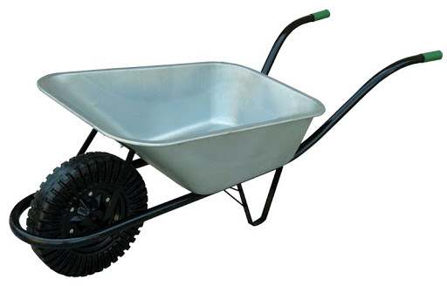](https://www.google.sk/url?sa=i&url=http://www.ttprod.sk/furik-stavebny-pozinkovany-koleso-tvrdy-bantam-80-l-p90722/&psig=AOvVaw0qeQgaNjqkoxrYBSqeco9B&ust=1588151208975000&source=images&cd=vfe&ved=0CAIQjRxqFwoTCOCm28PiiukCFQAAAAAdAAAAABAJ)[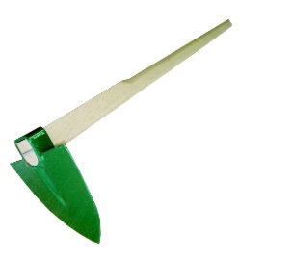](https://www.google.sk/url?sa=i&url=http://shop.ven.sk/sk/detail/108563-motyka-spicata-mala-s-nasadou-201&psig=AOvVaw0614QSyvlsXdLnUK6YeJ3C&ust=1588151920144000&source=images&cd=vfe&ved=0CAIQjRxqFwoTCIjXnIzliukCFQAAAAAdAAAAABAL)

FURÍK MOTYKA

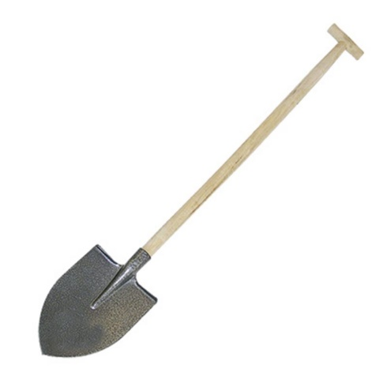[](https://www.google.sk/url?sa=i&url=https://www.greenshop.sk/hrable-oblukove-big-z18w-47-cm-18-zubov-drevena-lakovana-nasada-p1013947/&psig=AOvVaw2F6WCvMhAIkBZOl3GugI9a&ust=1588152446378000&source=images&cd=vfe&ved=0CAIQjRxqFwoTCJDq7YnniukCFQAAAAAdAAAAABAE)

RÝĽ HRABLE

NOŽNICE[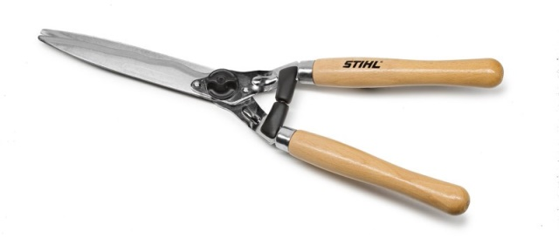](https://www.google.sk/url?sa=i&url=https://stihl.sk/produkt/rucne-noznice-na-zivy-plot/&psig=AOvVaw0Jr5LlnxdLOG79REbTvEI2&ust=1588152627000000&source=images&cd=vfe&ved=0CAIQjRxqFwoTCIj48ePniukCFQAAAAAdAAAAABAL)

Pracovné listy

V názvoch zeleniny zakrúžkuj písmenká **A E I O U**

PARADAJKA

REĎKOVKA

ZEMIAKY

UHORKA

HRÁŠOK

PETRŽLEN

Spojrovnaké s rovnakým

[](https://www.google.sk/url?sa=i&url=http://www.ttprod.sk/furik-stavebny-pozinkovany-koleso-tvrdy-bantam-80-l-p90722/&psig=AOvVaw0qeQgaNjqkoxrYBSqeco9B&ust=1588151208975000&source=images&cd=vfe&ved=0CAIQjRxqFwoTCOCm28PiiukCFQAAAAAdAAAAABAJ) [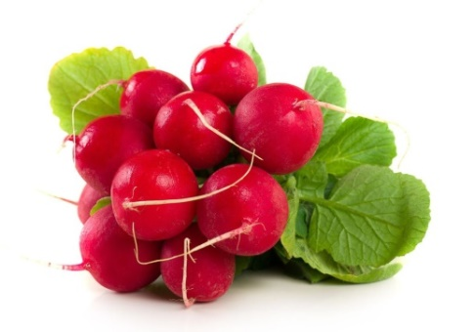](https://www.google.sk/url?sa=i&url=https://zena.pravda.sk/jedlo/clanok/463655-redkovka-nici-bakterie-a-rozpusta-zlcove-kamienky/&psig=AOvVaw0euniL9Pt6q6-h9ZEiwTFT&ust=1587626032178000&source=images&cd=vfe&ved=0CAIQjRxqFwoTCKij8Je---gCFQAAAAAdAAAAABAD)

[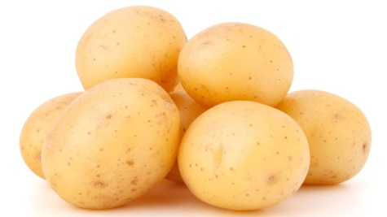](https://www.google.sk/url?sa=i&url=https://zdravie.pravda.sk/zdrava-vyziva/clanok/431544-kolko-sacharidov-denne-konzumovat-aby-sme-schudli/&psig=AOvVaw1IeX1mZF7M5N-YXEdwCpRU&ust=1588150414206000&source=images&cd=vfe&ved=0CAIQjRxqFwoTCIjpqsHfiukCFQAAAAAdAAAAABAM) [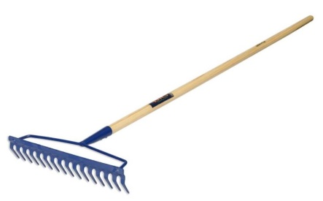](https://www.google.sk/url?sa=i&url=https://www.greenshop.sk/hrable-oblukove-big-z18w-47-cm-18-zubov-drevena-lakovana-nasada-p1013947/&psig=AOvVaw2F6WCvMhAIkBZOl3GugI9a&ust=1588152446378000&source=images&cd=vfe&ved=0CAIQjRxqFwoTCJDq7YnniukCFQAAAAAdAAAAABAE)

[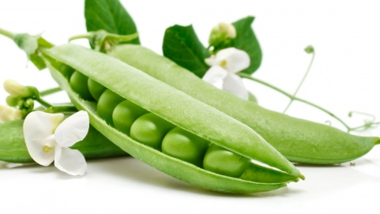](https://www.google.sk/url?sa=i&url=https://dran.webnoviny.sk/hrasok-plny-vitaminov/&psig=AOvVaw3gf5qNbQy_V9NZ6jFafvJP&ust=1588149589143000&source=images&cd=vfe&ved=0CAIQjRxqFwoTCPCN-7rciukCFQAAAAAdAAAAABAD) [](https://www.google.sk/url?sa=i&url=http://www.ttprod.sk/furik-stavebny-pozinkovany-koleso-tvrdy-bantam-80-l-p90722/&psig=AOvVaw0qeQgaNjqkoxrYBSqeco9B&ust=1588151208975000&source=images&cd=vfe&ved=0CAIQjRxqFwoTCOCm28PiiukCFQAAAAAdAAAAABAJ)

[](https://www.google.sk/url?sa=i&url=https://www.greenshop.sk/hrable-oblukove-big-z18w-47-cm-18-zubov-drevena-lakovana-nasada-p1013947/&psig=AOvVaw2F6WCvMhAIkBZOl3GugI9a&ust=1588152446378000&source=images&cd=vfe&ved=0CAIQjRxqFwoTCJDq7YnniukCFQAAAAAdAAAAABAE) [](https://www.google.sk/url?sa=i&url=https://stihl.sk/produkt/rucne-noznice-na-zivy-plot/&psig=AOvVaw0Jr5LlnxdLOG79REbTvEI2&ust=1588152627000000&source=images&cd=vfe&ved=0CAIQjRxqFwoTCIj48ePniukCFQAAAAAdAAAAABAL)

[](https://www.google.sk/url?sa=i&url=https://stihl.sk/produkt/rucne-noznice-na-zivy-plot/&psig=AOvVaw0Jr5LlnxdLOG79REbTvEI2&ust=1588152627000000&source=images&cd=vfe&ved=0CAIQjRxqFwoTCIj48ePniukCFQAAAAAdAAAAABAL) [](https://www.google.sk/url?sa=i&url=https://dran.webnoviny.sk/hrasok-plny-vitaminov/&psig=AOvVaw3gf5qNbQy_V9NZ6jFafvJP&ust=1588149589143000&source=images&cd=vfe&ved=0CAIQjRxqFwoTCPCN-7rciukCFQAAAAAdAAAAABAD)

[](https://www.google.sk/url?sa=i&url=https://zena.pravda.sk/jedlo/clanok/463655-redkovka-nici-bakterie-a-rozpusta-zlcove-kamienky/&psig=AOvVaw0euniL9Pt6q6-h9ZEiwTFT&ust=1587626032178000&source=images&cd=vfe&ved=0CAIQjRxqFwoTCKij8Je---gCFQAAAAAdAAAAABAD) [](https://www.google.sk/url?sa=i&url=https://zdravie.pravda.sk/zdrava-vyziva/clanok/431544-kolko-sacharidov-denne-konzumovat-aby-sme-schudli/&psig=AOvVaw1IeX1mZF7M5N-YXEdwCpRU&ust=1588150414206000&source=images&cd=vfe&ved=0CAIQjRxqFwoTCIjpqsHfiukCFQAAAAAdAAAAABAM)

Spoj čiarou veľkú zeleninu do veľkej misky a malú do malej misky[](https://www.google.sk/url?sa=i&url=http://www.tovar.sk/search/?q%3Dmiska%2Bvelka%2Bsalat%2Bsimax&psig=AOvVaw1gq_3SYi1OAmkD2sSVDRXF&ust=1588163447005000&source=images&cd=vfe&ved=0CAIQjRxqFwoTCOCKlLWQi-kCFQAAAAAdAAAAABAD) [](https://www.google.sk/url?sa=i&url=http://www.tovar.sk/search/?q%3Dmiska%2Bvelka%2Bsalat%2Bsimax&psig=AOvVaw1gq_3SYi1OAmkD2sSVDRXF&ust=1588163447005000&source=images&cd=vfe&ved=0CAIQjRxqFwoTCOCKlLWQi-kCFQAAAAAdAAAAABAD)[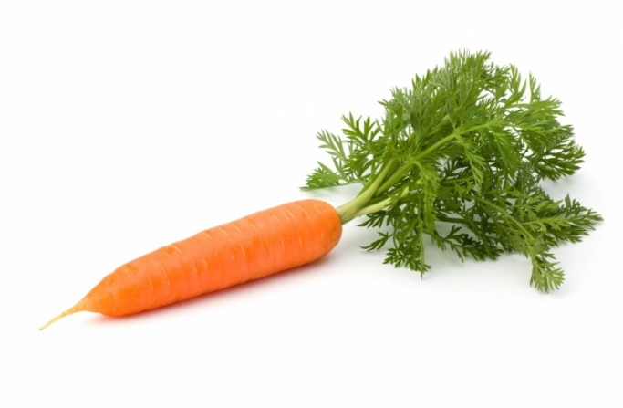](https://www.google.sk/url?sa=i&url=https://bylinke.sk/sk/stranka/bylinky/mrkva-obycajna&psig=AOvVaw3gsbqvPM6yNGT7-Zc1nOFf&ust=1588163806983000&source=images&cd=vfe&ved=0CAIQjRxqFwoTCIje6bCRi-kCFQAAAAAdAAAAABAD) [](https://www.google.sk/url?sa=i&url=https://zdravopedia.sk/zelenina/paradajky-10-ucinkov-na-zdravie&psig=AOvVaw2jSFnQU1v044QWb2-QU6u-&ust=1588163931772000&source=images&cd=vfe&ved=0CAIQjRxqFwoTCKChneuRi-kCFQAAAAAdAAAAABAD) [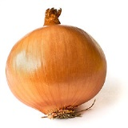](https://www.google.sk/url?sa=i&url=http://www.dotykbylinky.sk/mojblog/589/&psig=AOvVaw0t-n0X5qH0qo1lw6e4gcg-&ust=1588164857421000&source=images&cd=vfe&ved=0CAIQjRxqFwoTCNiW37GVi-kCFQAAAAAdAAAAABAD)[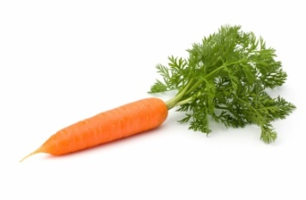](https://www.google.sk/url?sa=i&url=https://bylinke.sk/sk/stranka/bylinky/mrkva-obycajna&psig=AOvVaw3gsbqvPM6yNGT7-Zc1nOFf&ust=1588163806983000&source=images&cd=vfe&ved=0CAIQjRxqFwoTCIje6bCRi-kCFQAAAAAdAAAAABAD)[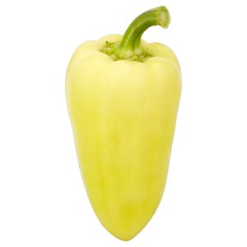](https://www.google.sk/url?sa=i&url=https://www.zlacnene.sk/akcia/paprika-biela/&psig=AOvVaw1eAjr-RKUhTzwgjsGww1P5&ust=1588164379003000&source=images&cd=vfe&ved=0CAIQjRxqFwoTCMi2w8KTi-kCFQAAAAAdAAAAABAD) [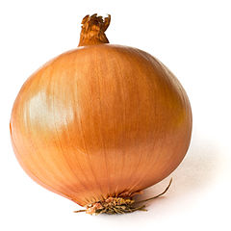](https://www.google.sk/url?sa=i&url=http://www.dotykbylinky.sk/mojblog/589/&psig=AOvVaw0t-n0X5qH0qo1lw6e4gcg-&ust=1588164857421000&source=images&cd=vfe&ved=0CAIQjRxqFwoTCNiW37GVi-kCFQAAAAAdAAAAABAD)

[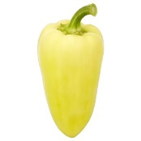](https://www.google.sk/url?sa=i&url=https://www.zlacnene.sk/akcia/paprika-biela/&psig=AOvVaw1eAjr-RKUhTzwgjsGww1P5&ust=1588164379003000&source=images&cd=vfe&ved=0CAIQjRxqFwoTCMi2w8KTi-kCFQAAAAAdAAAAABAD) [](https://www.google.sk/url?sa=i&url=https://zdravopedia.sk/zelenina/paradajky-10-ucinkov-na-zdravie&psig=AOvVaw2jSFnQU1v044QWb2-QU6u-&ust=1588163931772000&source=images&cd=vfe&ved=0CAIQjRxqFwoTCKChneuRi-kCFQAAAAAdAAAAABAD)